Name: M.Faizan, Abdullah Amin , Naveed Khan Roll No: 22Bscys034,07,54

Score: ____________Signature of the Lab Tutor: _______________ Date: 10/4/2023

# Add your project Title here

|  |  |  |  |  |  |  |  |
| --- | --- | --- | --- | --- | --- | --- | --- |
| **LAB PERFORMANCE INDICATOR** | **SUBJECT KNOWLEDGE** | **DATA ANALYSIS AND INTERPRETATION** | **ABILITY TO CONDUCT EXPERIMENT** | **PRESENTATION** | **CALCULATION AND CODING** | **OBSERVATION/ RESULTS** | **SCORE** |
| **OBJECTIVE NO:** |  |  |  |  |  |  |  |

**Group Member Names: Muhammad Faizan , Naveed Khan , Abdullah Amin**

**Github : https://github.com/MFiazan/Database_Project.git**

**Google Drive Links:** **https://drive.google.com/drive/folders/1zOYfAdmkx4nm65Xo61SzRYGUDKYnL-tL?usp=drive_link**

# Project Report: CRUD Application using HTML, Bootstrap, PHP, and MySQL

## Introduction

In today's digital age, data management plays a crucial role in various sectors, including business, education, and personal life. Creating, reading, updating, and deleting (CRUD) data are fundamental operations for any data-driven application. In this project, we have developed a CRUD application using HTML, Bootstrap, PHP, and MySQL to facilitate efficient data management.

### Project Objective

The primary objective of this project is to create a user-friendly web application that allows users to perform CRUD operations on a MySQL database. The application provides an intuitive and responsive user interface built with HTML and Bootstrap, while the backend functionality is powered by PHP to interact with the database.

### Tools and Technologies Used

1. **WampServer**: We chose WampServer as our local web development environment for its ease of setup and robust support for PHP and MySQL.
2. **Visual Studio Code (VS Code)**: VS Code is our preferred code editor for its extensibility, syntax highlighting, and debugging capabilities, making it an ideal choice for developing web applications.

## Project Details

### Features

Our CRUD application includes the following features:

1. **Create**: Users can add new records to the database using a user-friendly form.
2. **Read**: Users can view the existing records in a tabular format with pagination for easy navigation.
3. **Update**: Users can edit and update existing records.
4. **Delete**: Users can remove records from the database.

### Architecture

Our application follows a three-tier architecture:

1. **Presentation Layer (Frontend)**:
   * HTML and Bootstrap are used for creating the user interface.
   * JavaScript may be utilized for client-side validation and enhanced user experience.
2. **Application Layer (Backend)**:
   * PHP is used to handle user requests, process data, and communicate with the database.
   * PHP scripts are responsible for CRUD operations.
3. **Data Layer (Database)**:
   * MySQL is used as the relational database management system.
   * It stores and manages the application's data.

### Implementation Steps

1. **Database Setup**:
   * Create a MySQL database to store the application data.
   * Define the necessary tables and relationships.
2. **Frontend Development**:
   * Design and develop the user interface using HTML and Bootstrap.
   * Create forms for data input and tables for data display.
   * Implement client-side validation using JavaScript if needed.
3. **Backend Development**:
   * Write PHP scripts to handle CRUD operations.
   * Establish a connection to the MySQL database.
   * Implement PHP functions for creating, reading, updating, and deleting records.
4. **Integration**:
   * Integrate the frontend and backend to ensure seamless communication.
   * Implement URL routing and request handling in PHP.
5. **Testing**:
   * Thoroughly test the application to ensure data integrity and functionality.
   * Perform unit testing, integration testing, and user acceptance testing.
6. **Deployment**:
   * Deploy the application on a web server if needed for public access.
7. **Documentation**:
   * Create documentation that includes a user manual and technical documentation for future reference.
8. **Maintenance and Updates**:
   * Provide ongoing maintenance and support for the application.
   * Consider future enhancements and updates based on user feedback and requirements.

### Conclusion

In conclusion, our CRUD application using HTML, Bootstrap, PHP, and MySQL provides an efficient and user-friendly solution for data management. It enables users to perform essential CRUD operations on a MySQL database with ease. This project demonstrates the integration of frontend and backend technologies to create a practical web application that can be used in various domains for efficient data handling.

Top of Form

Regenerate

**Snapshot:**

**DATABASE:**

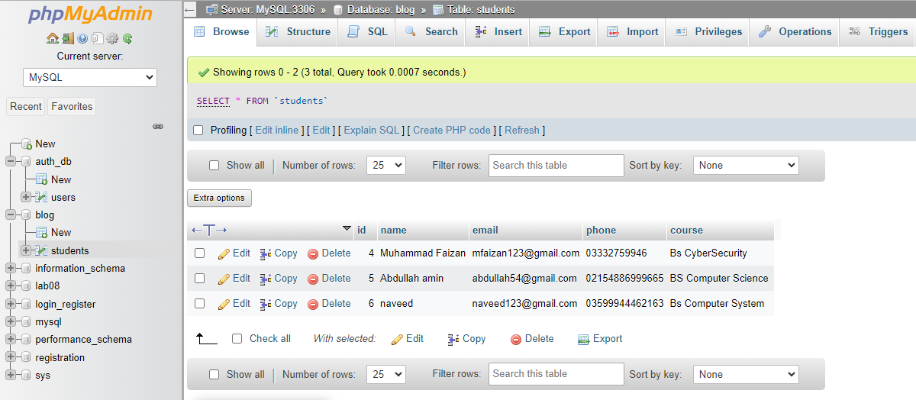

**Web APPLICATION SNAPSHOTS:**

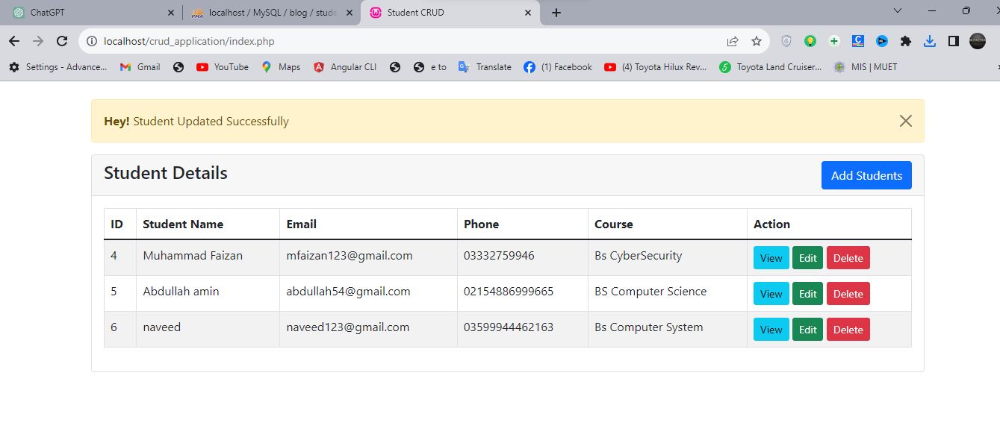

**Students Details page :**

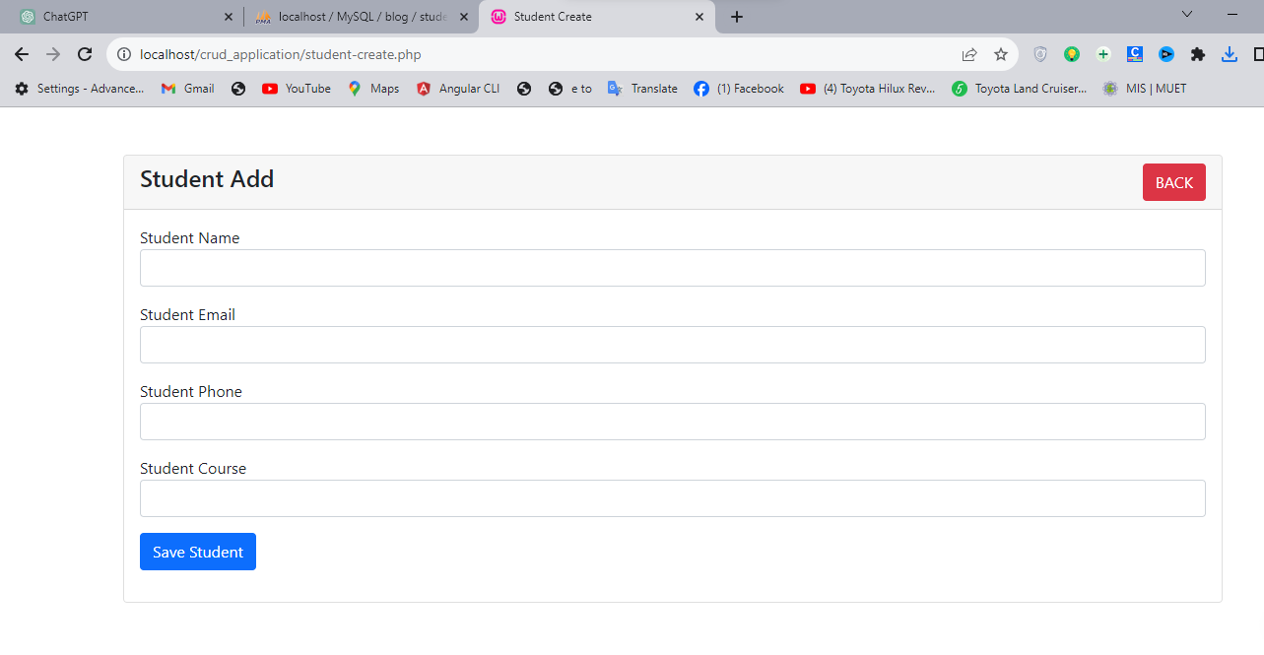

**Student Record Add Page :**

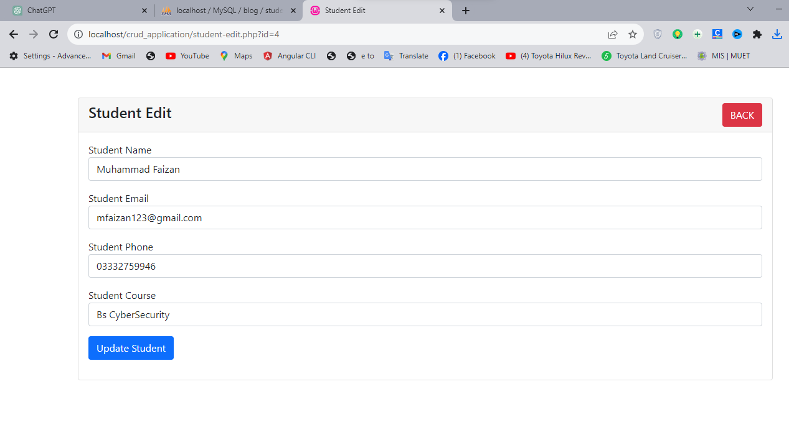

**Student Edit Page :**

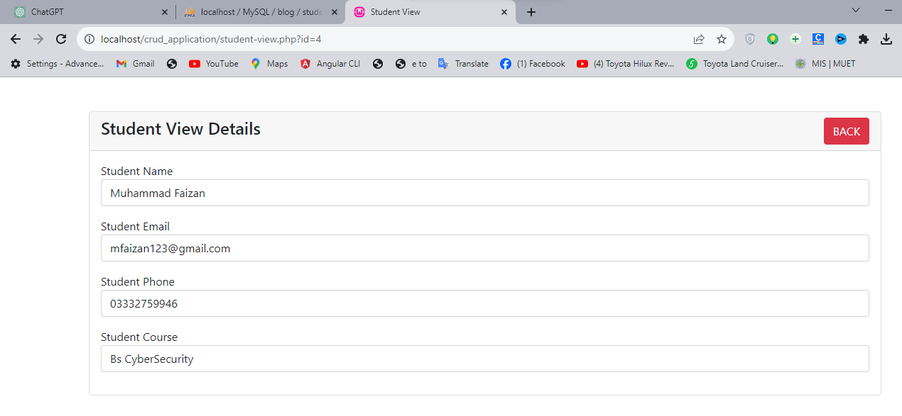

**Student View Details Page:**

**The End:**